Folded normal distribution

Def

A normal distribution whose density is foled.

See following figure in PDF section.

PDF

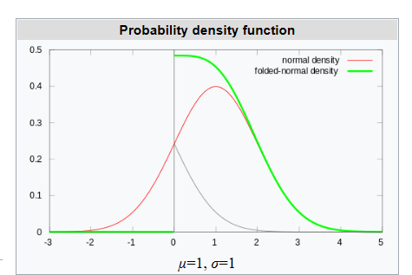

$$f_{X}\left(x,E\left[X\right],std{\left(X\right)}^{2}\right)$$

= $$\frac{1}{\left(2⋅pi\left(\right)⋅std{\left(X\right)}^{2}\right)}e^{−\frac{{\left[Z_{1}\left(x,E\left[X\right],std\left(X\right)\right)\right]}^{2}}{2}}+\frac{1}{\left(2⋅pi\left(\right)⋅std{\left(X\right)}^{2}\right)}e^{−\frac{{\left[Z_{2}\left(x,E\left[X\right],std\left(X\right)\right)\right]}^{2}}{2}}$$

where

$$Z_{1}\left(x;E\left[X\right],std\left(X\right)\right)$$ = $$\frac{\left(x−E\left[X\right]\right)}{std\left(X\right)}$$

$$Z_{2}\left(x,E\left[X\right],std\left(X\right)\right)$$ = $$\frac{\left(x+E\left[X\right]\right)}{std\left(X\right)}$$

CDF  
Expected Value

$$Mean\left(X,E\left[X\right],std\left(X\right)\right)$$

= $$std\left(X\right)⋅{\left(\frac{2}{pi\left(\right)}\right)}^{\frac{1}{2}}e^{−{\left(\frac{E\left[X\right]}{std\left(X\right)}\right)}^{2}}+E\left[X\right]⋅erf\left(\frac{E\left[X\right]}{{\left(2⋅std{\left(X\right)}^{2}\right)}^{\frac{1}{2}}}\right)$$

Variance

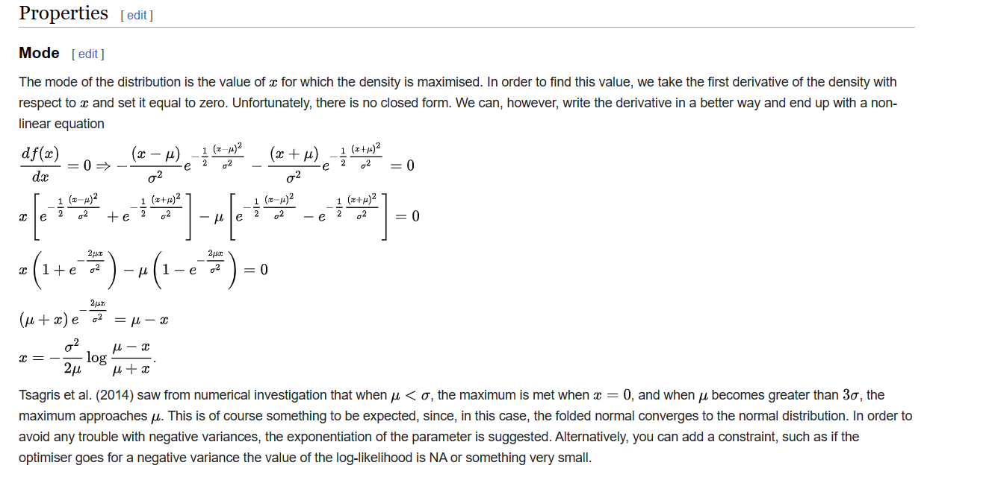

Skewness

Median

Mode

Ref

[Folded normal distribution - Wikipedia](https://en.wikipedia.org/wiki/Folded_normal_distribution)